I have implemented a dynamic parallel loop using a Block step with ParForEach.
Setting an End Condition allows us to exit the block prematurely—for example, if any single approver selects 'Reject,' all remaining parallel work items are immediately canceled, and the workflow proceeds to the next step. However, the exact behavior depends on the underlying business requirements.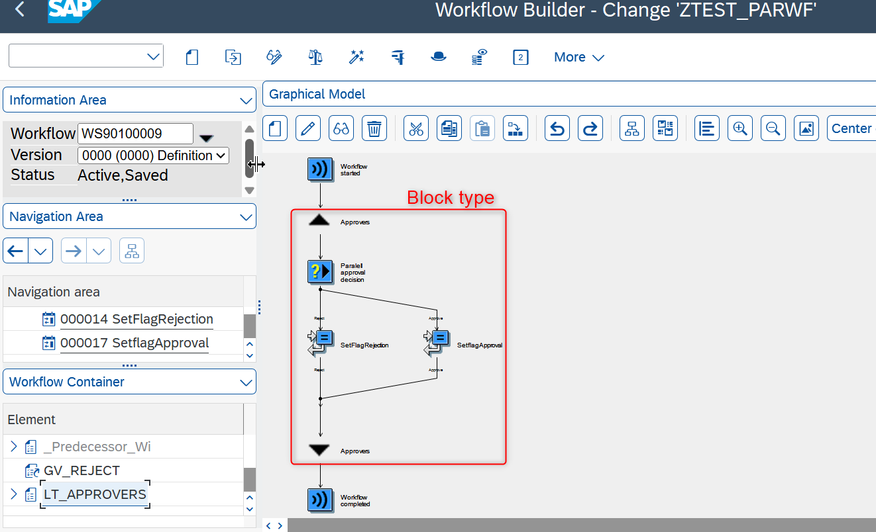
We'll configure the block's end condition to trigger when the global variable GV_REJECT is 'X'. The variable is updated to 'X' as soon as one approver rejects the request.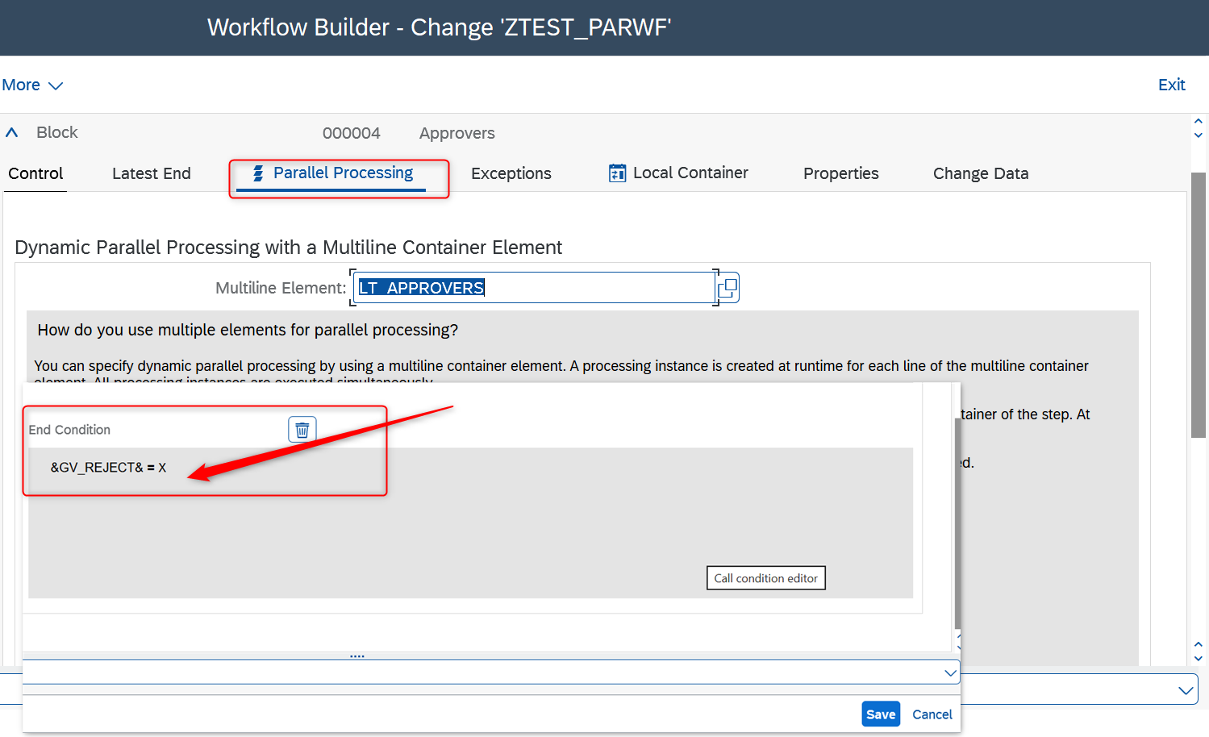
For this workflow test, I set three fixed approvers in the internal table variable LT_APPROVERS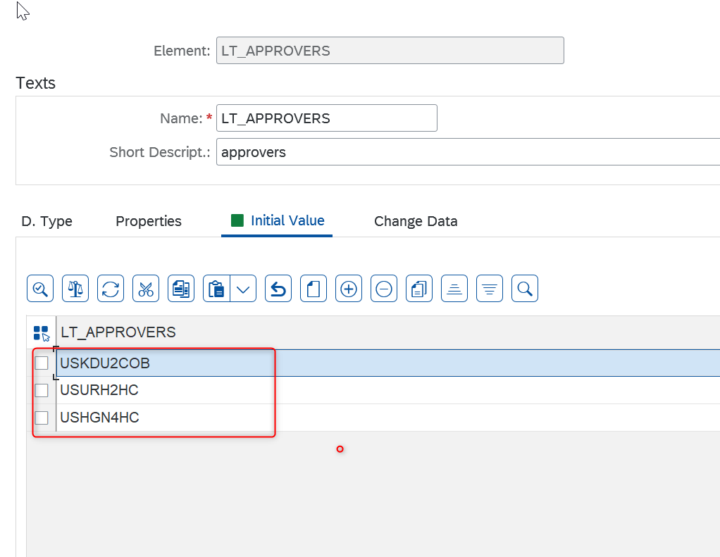

I ran a test for our custom parallel approval process using transaction code SWUS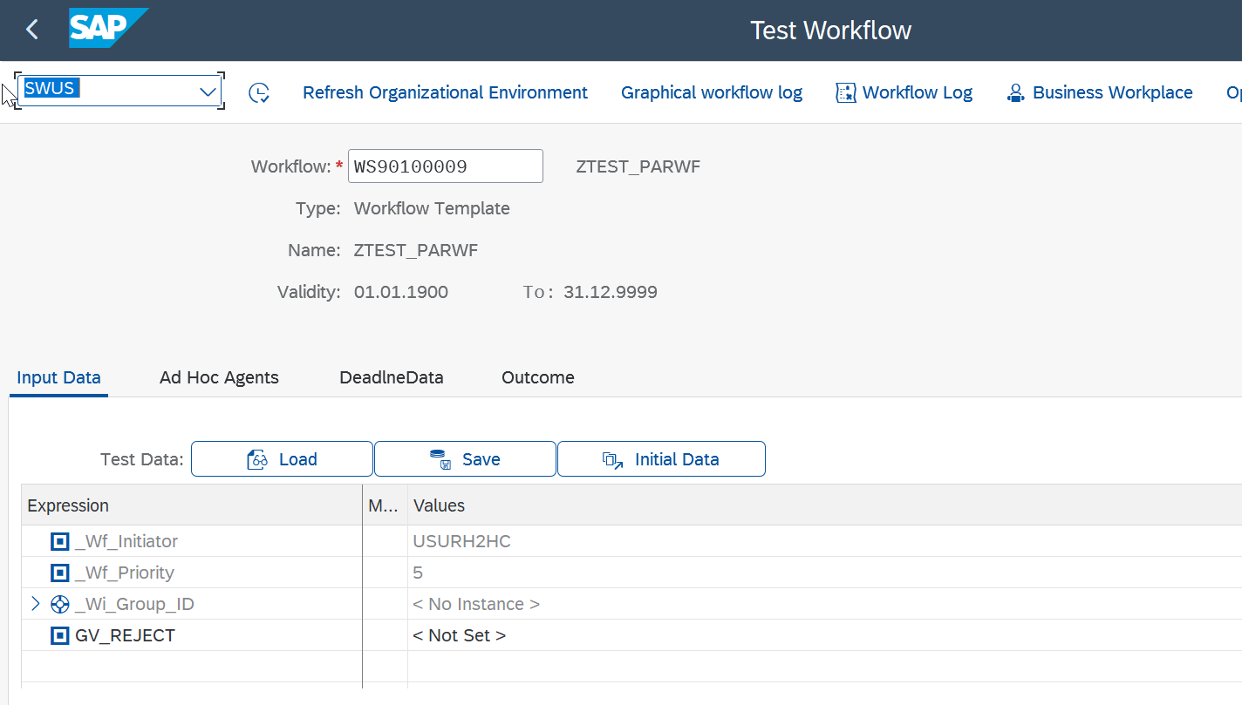

Check in Workflow log in tcode SWIA.
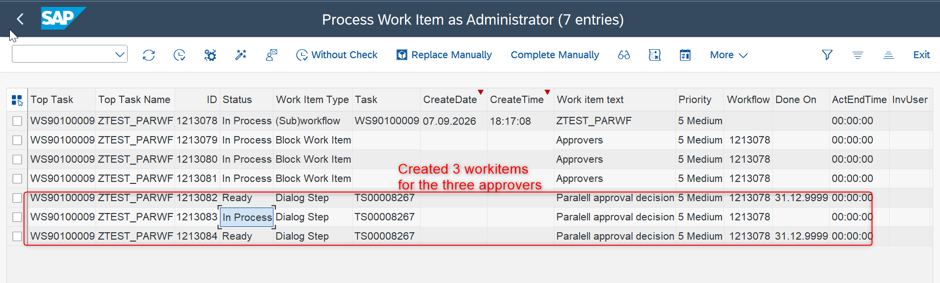

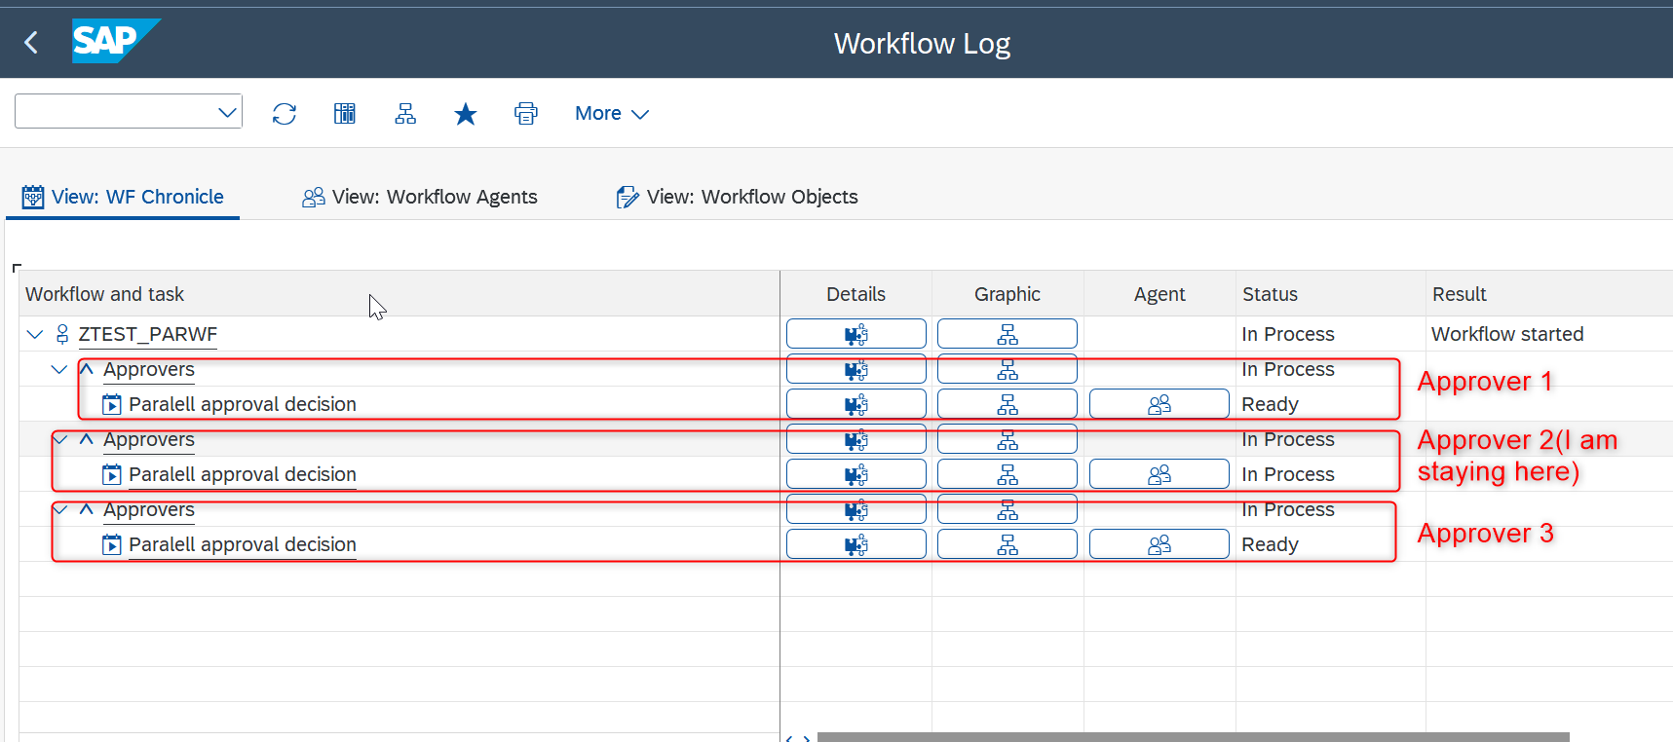

Now, I will go to the SAP Business Workplace to perform the rejection.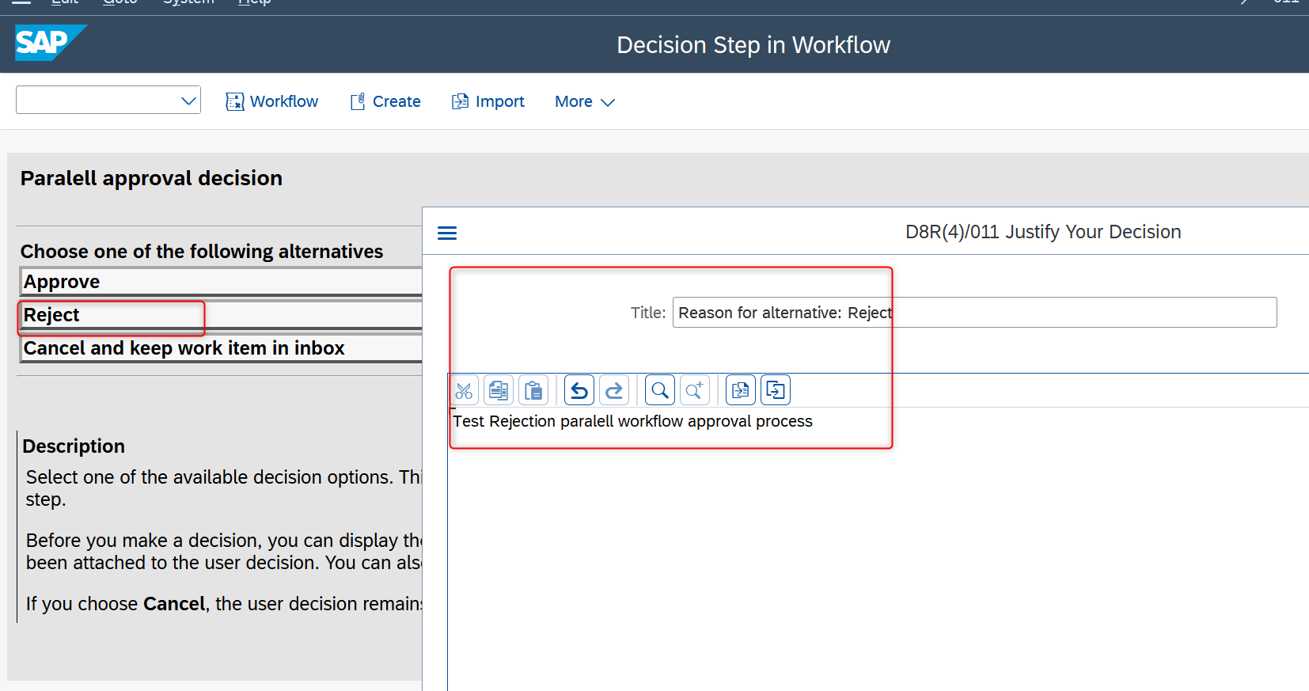
After I reject the request, all remaining work items assigned to the other approvers will be canceled. This is the standard behavior of SAP workflows